CM S/W User’s Manual
(Model: IRIS-04/08/16L)
IRIS-net viewer (16ch) / IRIS CMS viewer (64ch)
Web Viewer (Internet Explore) Program (4/8/16ch)

Table of Contents

- Client Software Installation

- Client Software Operations
- Client Software ( IRIS Viewer Software and File Player)

- IRIS Viewer Features

- File Player Features

- Main GUI of IRIS Net-Viewer Software

- Main GUI of File Player Software

6) IRIS Net-Viewer Software Operation
6-1) Network Connection
6-2) Network Disconnection
6-3) Image Display Widow Selection
6-4) PTZ Control Mode
6-5) Local Setting
6-6) Remote Setting
6-7) REMOTE SEARCH
6-8) CAPTURE
6-9) RECORD
6-10) MIC ON, Volume Control and Mute
6-11) Event Notification (Alarm, Motion) from remote DVR

7) File Player Software Operation
7-1) Folder Open
7-2) File Open
7-3) Channel Select
7-4) Single Channel Select
7-5) Volume Control and mute
7-6) Setting
7-7) Power
7-8) Playback Icons (It is related to playback function)
7-9) Fast Playback
7-10) Capture (SAVE, PRINT)
7-11) File Conversion ( from H.264 to AVI)

8) Web Viewer (Internet Explore Viewer) Program Operation

1. Client Software (Net-Viewer, File Player) Installation

CAUTION: If an older version of Net-viewer software or similar viewer software has been already installed on your computer, you should uninstall the software first.

1) Insert the installation CD.
– You have 16 CH NetViewer zip file and 64 CH NetViewer zip file
– Unzip the intallation file (each NetViewer zip file)
2) Run the Setup.exe file. And following dialog box will be appeared.
Please wait a few seconds.

3) When the following dialog box appears, click Next

4) Please keep click Next in following dialog box when the following dialog box appears

5) Installation is finished. And Net_View, and File_Player icon will be shown in PC as below picture

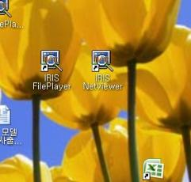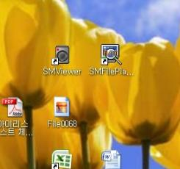

16Ch NetViewer – IRIS NetViewer & File Player 64Ch NetViewer – SM NetViewer & FilePlayer

- Client Software Operations

1) Client Software
H.264 Client Software consist of NetViewer, and File Player.
* There are two kinds of NetViewer remote program
– 16 ch NetViewer (IRIS NetViewer Program)
– 64ch Net-Viewer (SM Viewer Program)

Net_Viewer S/W is Main client viewing S/W. Major function is Network Connection,
Live Monitoring and network functions
File Player is for file playback software. Its major function is each file playback
and File conversion from H.264 to AVI.
* Required minimum PC System for Client Software
- Operation System: MS Windows 2000, XP, Vista, Windows7
- CPU: Intel Pentium II 266MHz or higher
- RAM: 64MB or Higher
- VGA: AGP, Video RAM 8MB or Higher

2) NetViewer Features
NetViewer Program support such as functions;
- Static, Dynamic IP and DDNS support
- Remote Live camera Monitoring
- Remote file searching, Backup, Playback
- PTZ camera control
- Remote Configuration and Firmware Upgrade
- Multi-user accessing support
- Full duplex two way audio transmission
- Event (Alarm, Motion) Notification

3) File Player Features
- Each file playback
File conversion from H.264 to AVI or JPEG]

4-1) Main GUI of NetViewer Software (64CH – SM Viewer Program)

< ICON description >

No. | Icon Description
1 | Network Connection and Disconnection
2 | Display Channel Selection for Full screen, QUAD, 8 picture and 16 picture display
3 | PTZ control for Pan, tilting, zooming and focusing
4 | Local Setting for OSD display and saving directory.
5 | Remote Setting for menu configuration
6 | Log View & E-Map
7 | Audio Volume Control
8 | Audio Mute ON/ OFF
9 | Microphone ON/OFF for two way audio communication.
10 | Recording in local PC.
11 | Capture Start for single picture printing and saving.
12 | Remote Searching

4-2) Main GUI of NetViewer Software (16CH – IRIS NetViewer Program)

No. | Icon Description
1 | Network Connection and Disconnection
2 | PTZ control for Panning , Tilting, zooming and focusing
3 | PTZ control for presetting camera function
4 | Remote Searching
5 | Remote Setting for menu configuration,
6 | Config (Local) Setting for OSD display and saving directory
7 | Health Check
8 | Display Channel Selection for Full screen, QUAD, 8 picture and 16 picture display
9 | Capture Start for single picture printing and saving
10 | Recording in local PC.
11 | Log View
12 | Audio Mute ON/ OFF / Audio Volume Control / Microphone ON/OFF for two way audio communication.

5) Main GUI of File Player Software

< ICON description >

No. | Icon Description
1 | Folder Open for playback
2 | File Open for playback.
3 | Capture Start for single picture printing and saving.
4 | File Conversion from H.264 to AVI format
5 | Audio Volume Control and Mute ON/ OFF
6 | Local Setting for OSD setting
7 | Program Exit (Power Button)
8 | Display Channel Selection for Full screen, QUAD, 9 picture and 16 picture display
9 | Full Screen Selection
10 | Playback buttons for normal play, Still/ Pause, Fast playback.
11 | Fast Playback for forward and backward with scroll bar

6) NetViewer Software Operation (64ch)

6-1) Network Connection
When click this “CONNECT” button , “CONNECT GROUP” window will
be appeared like below

< How to use 64CH NetViewer Software for GROUP and ADDRESS>

A) How to add “CONNECT GROUP ”
- NAME: Arbitrary name which can be remembered easily or be differentiated can be filed in “Group Name”. Press “Add Group” button, then the group will be added to the list as shown below

B) Add the First Site:
- While the created group is selected, fill out the site information.
- Then select channels to be connected from this site.
- Please note that each site name must be created uniquely.
- Duplicated site name is not allowed even for different group.
- Click ADD to add this site information to the list as shown below.

C) Add the second Site:
- Add the second site information.
- Then the Site will be configured as shown below

D) Notice :
- ADDRESS: The IP address of DVR which want to access can be written in
This IP address can be confirmed in “IP address of NETWORK menu” in DVR.
- PORT number: default is “10000”. ( It is different according to network environment.)
- USER is assigned as “ADMIN” initially.
- PASSWORD: The “password of DVR” which want to access should be input here.
If the password is not correct, network connection will be failed.
The requested password is same as the DVR password.
- If “ADD” is clicked after all the parameter including “ NAME”, “ADDRESS”, “PORT”,
“USER” & “PASSWORD”, new “CONNECT ADDRESS” will be enrolled in address list.
- One of easier way to add “CONNECT ADDRESS” is to click “ADD” after modification of “CONNECT ADDRESS” using “MODIFY”. It can be useful to add “CONNECT ADDRESS”, when there is at least one address list.
- When you want to delete one of site list, select one of listed “ADDRESS” which want
to remove and then click “DELETE” to remove it.
- How to modify “CONNECT ADDRESS”, select one of listed “ADDRESS” which want
to modify and modify one of NAME, ADDRESS usually. Then click “MODIFY” to
modify it.
- Connect network, select one of listed “ADDRESS” which want to connect. If
network connection is succeeded, “Connect Success” will be appeared in PC with
message. If not, error message will be displayed after for a while.

E) Example of “Connect Success”.

6-2) Image Display Widow Selection

A) Full Screen Display B) QUAD Picture Display

C) 8 Picture Display D) 16 Picture Display

E) 36 Picture Display F) 64 Picture Display

If one of 64ch pictures is double-clicked, the channel will become to be full picture. It return to 64 picture display with double-click once again.

6-4) PTZ Control Mode

Function | Button | Button Description
Pan  and  Tilting  Icon |  | Move to Left Up and move to Up.
 |  | Move to Right Up and move to Left.
 |  | Move to Left and move to Left Down.
 |  | Move to Down and move to Down Right
Zoom |  | Zoon Out
 |  | Zoon In
Focus |  | Focus Far
 |  | Focus Near
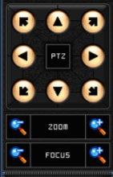

PTZ Control feature of camera(s) if available. Select a PTZ capable camera before
click to control. The PTZ feature must be physically configured on the DVR system
prior to the operation.
Zoom: Control zoom in and out for the camera.
Focus: Control focusing + and – for the camera.
Directions: To move respective directions.

6-5) Local Setting Mode
Configure setting on the local computer that is running NetViewer / SMViewer

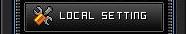  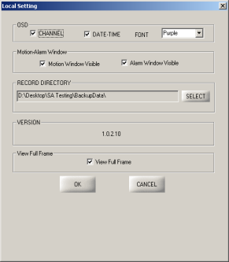 | - OSD: Select and configure on screen display option for CHANNEL, DATE-TIME, and FONT color to display.  - Motion-Alarm Window: Turn on or off for motion or alarm notification window. If checked a small window will pop up with event information each time event is triggered.  - RECORD DIRECTORY: Select a folder location to store recorded data. Files recorded by RECORD button will be saved into this location. “C:\DVRBACKUP\” is the default.  - VERSION: Display the version of Net_Viewer  - View Full Frame: Allow to transmit all available frames. Once checked, the amount of data will be significantly increased. Make sure to use this feature under local network connection only.  - OK: Apply changes and exit local setting.  - CANCEL: Exit local setting without saving changes

6-6) Remote Setting
After clicking “REMOTE SETTING” icon, if there is no trouble in network connection between remote DVR and local PC with NetViewer, below NetViewer GUI will be appeared.
In order to change settings on the DVR System from remote connection, press REMOTE SETTING button next to the REMOTE SEARCH. The user must be authorized to access setting.

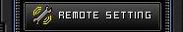

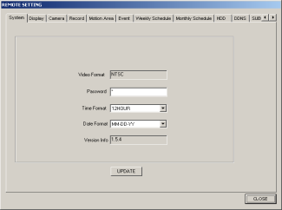

A) System Setting

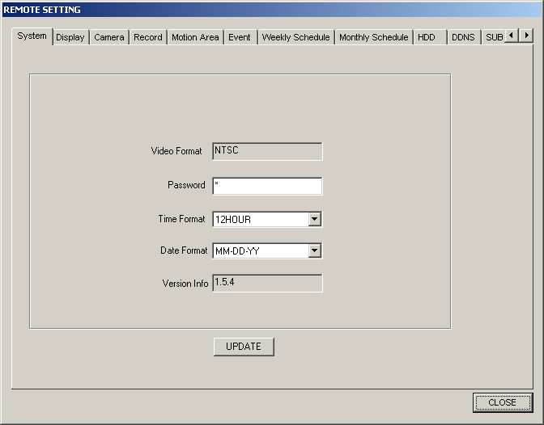

- Video Format: Display video type connected to the system.
- Password: Password for the current user logged in.
- Time Format: Select a format to display time.
- Date Format: Select a format to display date.
- Version Info: Display the firmware version of the system.
- UPDATE: Upload and apply any changes made to the system

B) Display Setting

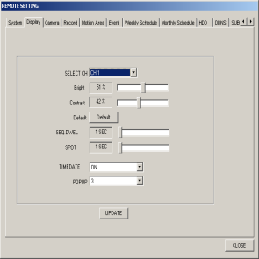

- SELECT CH: Select a channel to apply sub-settings.
- Bright: Adjust brightness from 1 ~ 99%.
- Contrast: Adjust contrast from 1 ~ 99%.
- Default: Back to default (50%).
- SEQ. DWEL: Select dwelling time for Sequential display.
- SPOT: Select dwelling time for the spot output.
- TIMEDATE: Turn on/off on screen display of time & date.
- POPUP: Select a number of seconds to display event triggered popup, or set to OFF turn off popup.
- UPDATE: Upload and apply any changes made to the system.
C) Camera Setting

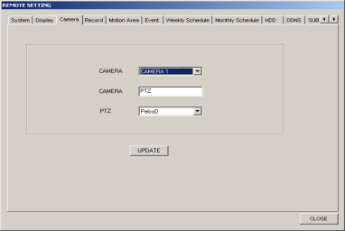

CAMERA: Select a camera number to apply changes.
CAMERA ID: Set camera name. Alpha-numeric name up to 10 characters can be assigned.
PTZ: Select a protocol for PTZ camera if applicable. Detail setting must be adjusted on the system with hardware configuration.
UPDATE: Upload and apply any changes made to the system

D) Record Setting

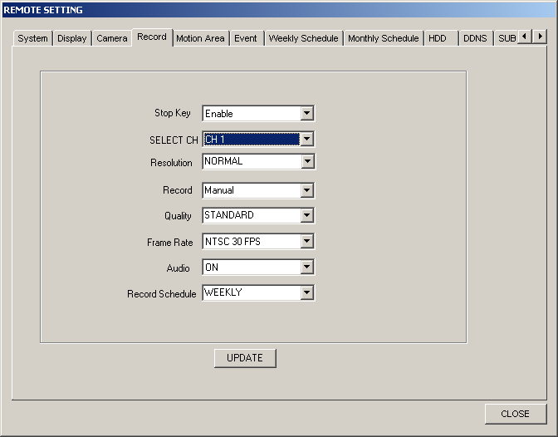

Stop Key: Enable or disable the manual interruption of recording, using STOP button on the actual system.
SELECT CH: Select a channel to apply sub-settings.
Resolution: Select from FULL (4 CIF/D1), HALF (2 CIF/Half D1), or NORMAL (CIF)
Record: Select from Disable (OFF), Manual, Schedule, or Event for recording type.
Quality: Select from VERY LOW, LOW, STANDARD, HIGH, and VERY HIGH
Frame Rate: Select from a recording frame rate from 1 to 30 on NTSC (1 to 25 PAL).
Audio: Select ON or OFF for audio recording.
Record Schedule: Select from None, WEEKLY, or MONTHLY for recording type.
UPDATE: Upload and apply any changes made to the system.

E) Motion Setting

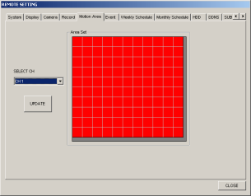

- SELECT CH: Select a channel to adjust motion detecting area.
- Area Set: Click on a segment to change color between red and white. A segment with white color will not detect motion.
- UPDATE: Upload and apply any changes made to the system.

F) Event Setting

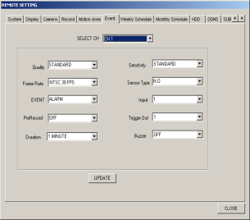

- SELECT CH: Select a channel to apply event setting.
- Quality: Select from VERY LOW, LOW, STANDARD, HIGH, and VERY HIGH
- Frame Rate: Select from a recording frame rate from 1 to 30 on NTSC (1 to 25 PAL).
- EVENT: Select ALARM or MOTION
- PreRecording: Turn Pre-event recording ON or OFF
- Duration: Assign recording time from 30 sec up to 60 min.
- Sensitivity: Select from VERY LOW, LOW, STANDARD, HIGH, and VERY HIGH
- Sensor Type: Select sensor type between NO and NC.
- Input: Select an Input from 1 ~ 16.
- Trigger Out: Select a relay output from 1 ~ 4.
- Buzzer: Turn ON or OFF the audible warning upon event detection.

G) Weekly Setting

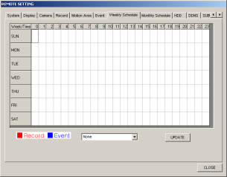 | Schedule recording by 24 hours by days of the week, from Sunday through Saturday.  Recording Type: Select from None, Record, and Event  Scheduling: Click on the grid to select a segment, or click and drag to select a period. Currently selected recording type will be applied to segment(s) clicked.  Red color indicates recording, blue indicates event triggered recording, and white indicates no recording.  UPDATE: Upload and apply any changes made to the system.

H) Monthly Sett

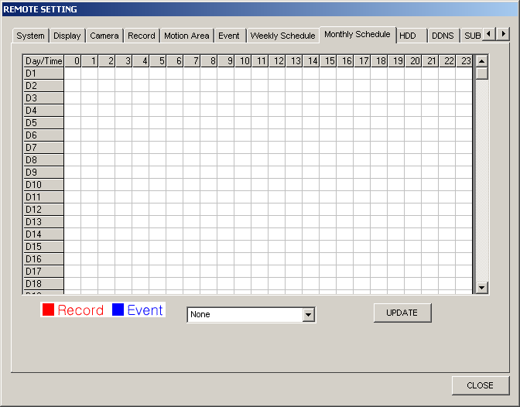 | Schedule recording by 24 hours by days of the month, from 1 through 31.  Recording Type: Select from None, Record, and Event.  Scheduling: Click on the grid to select a segment, or click and drag to select a period. Currently selected recording type will be applied to segment(s) clicked.  Red color indicates recording, blue indicates event triggered recording, and white indicates no recording.  UPDATE: Upload and apply any changes made to the system.

I) HDD Setting

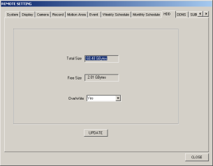 | Total Size: Display total size of installed hard drive(s).  Free Size: Display available size of installed hard drive(s).  OverWrite: Select Yes or No to overwrite once hard drive is full.  UPDATE: Upload and apply any changes made to the system.

J) DDNS Setting

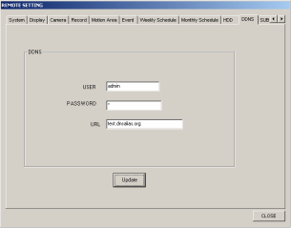 | Allow the user to use a selection of a third party DNS service. Complete information and click on update to utilize. It is strongly recommended to use DNS service provided at default. The compatibility is depending on the service type. Please use this feature at your own discretion after testing.  - User ID: Enter the login ID information.  - Password: Enter the password.  - URL: Enter the URL of DNS.

K) Sub User Setting

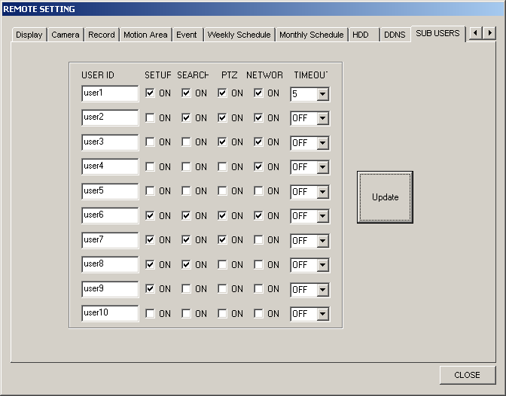 | Change properties of each sub users. This page is only available to the administrator. Therefore, it is necessary to log in with ‘admin’, in order to change these settings.  - USER ID: Assign a name for each user.  - SETUP/SEARCH/PTZ/NETWORK: Check to allow the user to use the feature. For example, ‘user8’ can only access setting and search from the unit, but cannot control PTZ or connect remotely. On the other hand, ‘user3’ can remotely connect and control PTZ, but cannot access setting or search.  - TIME OUT: Select a number in minutes to automatically disconnect the user from the remote connection. OFF, 5, 10, 15, 30, and 60 are available to select.

6-7) REMOTE SEARCH (for Playback and File downloading)

“REMOTE SEARCH” can be utilized for not only searching the files saved in remote
DVR, playback of searched files but also backup of some of important files by FTP.
“ REMOTE SEARCH” icon of main GUI of NetViewer is clicked, below sub GUI will
be appeared as below figure.

Display calendar to select a date to playback

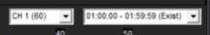 Display currently selected channel and time segment information

Display legend (color code) of recorded data. Data segments with red
color indicated manually recorded, yellow, blue, and pink indicate alarm, motion, and schedule recording respectively.

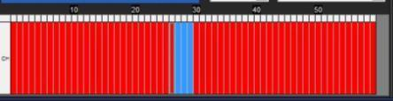

Display available recorded data segments in red for the segment selected from above. Each segment indicates a minute of the hour and channel selected.
Multiple segments (time period) can be selected for consecutively located red segments, by click and drag from a segment to segment.
On the playback information (section 1), the information of left far segment selected will be displayed on the Start, and the right far segment on the End.

After selecting date from calendar, channel, hour and minute in above picture, “PLAY” buttons for playback can be pressed. For more control features, such as fast forward or rewind, download segments to the local computer and use File_Player.exe to playback.

Download selected segments (time period) to the local computer. Downloaded file will be stored at the location assigned from local setting, RECORD DIRECTORY section. (“C:\DVRBACKUP” at default).

Display playback information.
Time: Display the recorded time of the image currently playing
Start: Display the start time of the currently selected segments (time period) to playback or download.
End: Display the end time of the currently selected segments.

Turn off the remote search and return to the main screen of Net_Viewer.

Example:
To playback and download CH2 recorded data on 15th at 9:31 AM ~ 9:32 AM.
(Current date is 16th).

6-8) CAPTURE (Picture saving and Printing)

“CAPTURE” can be utilized for not only single picture saving but also picture printing.
When “CAPTURE” icon is pressed, sub-GUI of “CAPTURE” will be appeared as below
figure. “SAVE” or “PRINT” icon can be selected for either picture saving or picture
printing.

When “SAVE” icon is pressed, below sub-GUI of “SAVE” will be appeared and
picture saving path will be requested as below figure. The file format for saving single
picture is standard JPEG.

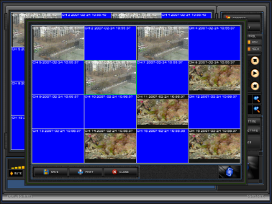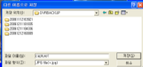

When “PRINT” icon is pressed, below sub-GUI of “PRINT” will be appeared and
picture printing path will be requested as below figure. The Selected picture will be
printed.

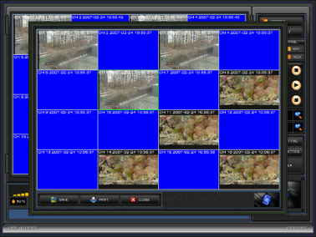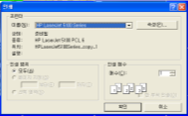

When “PRINT” icon is pressed, below sub-GUI of “PRINT” will be appeared and
picture printing path will be requested as below figure. The Selected picture will be
printed.

6-9) RECORD

“RECORD” can be utilized for saving live picture coming from remote DVR in local PC.
If there is no changing of saving path to save picture, picture will be save in
C:\DVRBACKUP. When “ RECORD” icon is pressed, recording will be started with
brighter “RECORD” icon like below figure . If “ RECORD” icon is pressed again,
recording will be stopped with dark “RECORD” icon like .

6-10) MIC ON, Volume Control and Mute

For full duplex two way audio communication, the activation of microphone will be needed. “MIC ON” icon can be pressed for “Microphone ON”. “MIC ON” icon will be turn into activation of “MIC ON” icon .

For audio reproduction, single channel which want to listen audio should be selected
first using Single Channel Select or double click of that channel. The audio volume can
be adjusted by dragging of left button of mouse in .

6-11) Event Notification (Alarm, Motion) from remote DVR
If motion in any channel is(are) detected or alarm is (are) triggered in any remote DVR,
event information will be noticed to CMS software as below picture. CMS software
shows additional “Ëvent Window”, with corresponding event information, .
If “VIEW” icon in Ëvent Window” is clicked, full screen will be displayed. If “CLOSE” is
clicked, “Ëvent Window” will be disappeared. But those event information is stored in
Log data and is displayed in continuously.

